Base Server:

1. Proxy Installation :

<https://cloud.google.com/sql/docs/mysql/sql-proxy#install>

Systemctl disable mysql  
  
Systemctl stop mysql

2. Authenticate proxy to database with service account

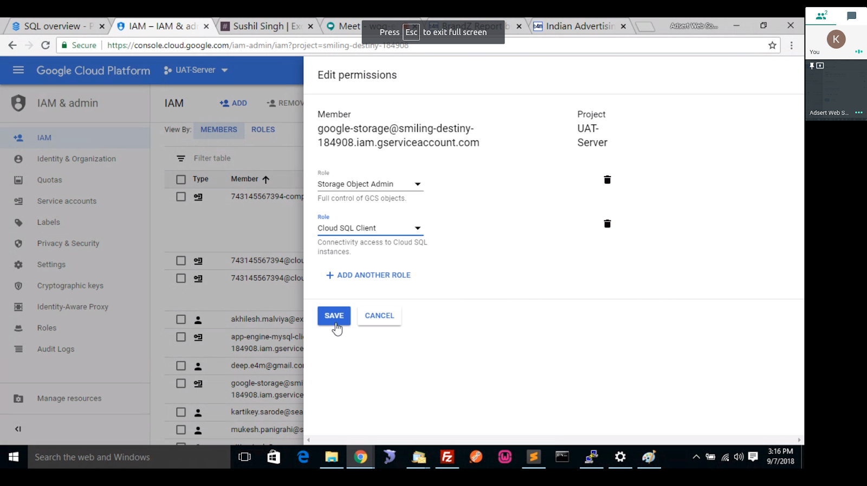

sudo find . -name "key.json"

**PROXY command** → ./cloud_sql_proxy -instances=smiling-destiny-184908:asia-south1:uat-exchange4media=tcp:3306 -credential_file=key.json

3. **INSTALL Supervisor (monitor the proxy process)**

<https://www.digitalocean.com/community/tutorials/how-to-install-and-manage-supervisor-on-ubuntu-and-debian-vps>

systemctl enable supervisor

systemctl start supervisor

systemctl status supervisor

Path of supervisor config:

/etc/supervisor/conf.d/

cloudsqlproxy.conf

[program:cloudsqlproxy]

directory=/root

command=/root/./cloud_sql_proxy -instances=production-server-185509:asia-south1:exchange4media-production=tcp:3306 -credential_file=key.json

autostart=true

autorestart=true

stderr_logfile=/var/log/cloudsqlproxy/cloudsqlproxy.err.log

stdout_logfile=/var/log/cloudsqlproxy/cloudsqlproxy.out.logto check the running service

sudo su

supervisorctl

ps -ef | grep proxy

how to manually start the service

start cloudsqlproxy

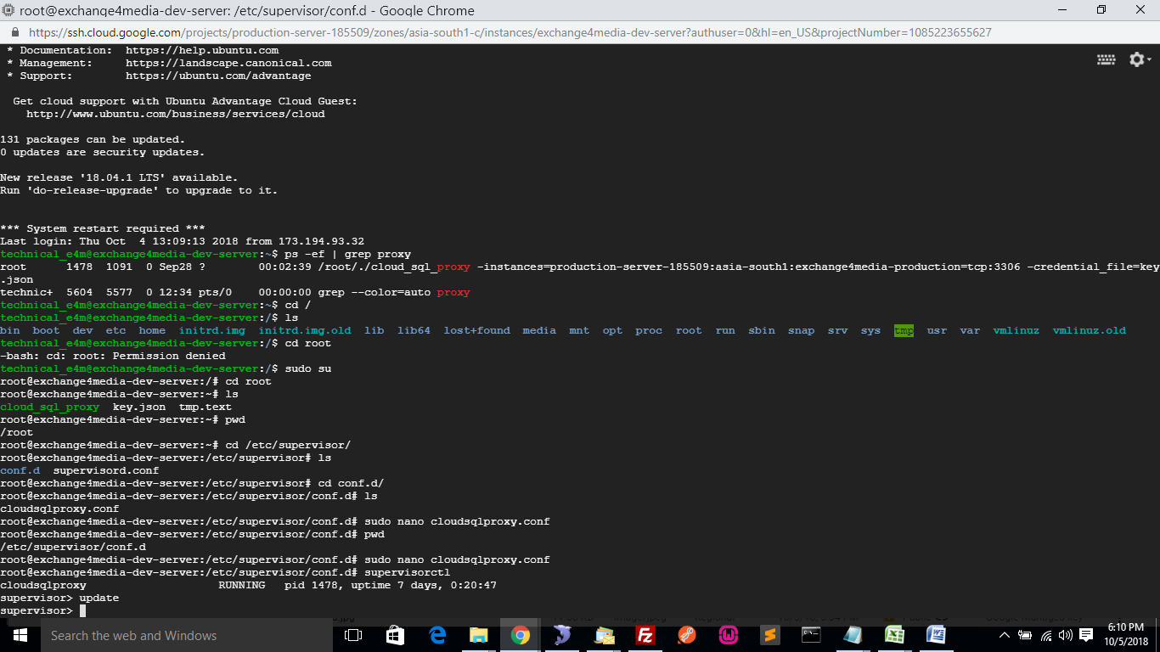

**4. For connecting to DB use 127.0.0.1:3306 (this will use the proxy to connect to DB)**

**Image Creation**

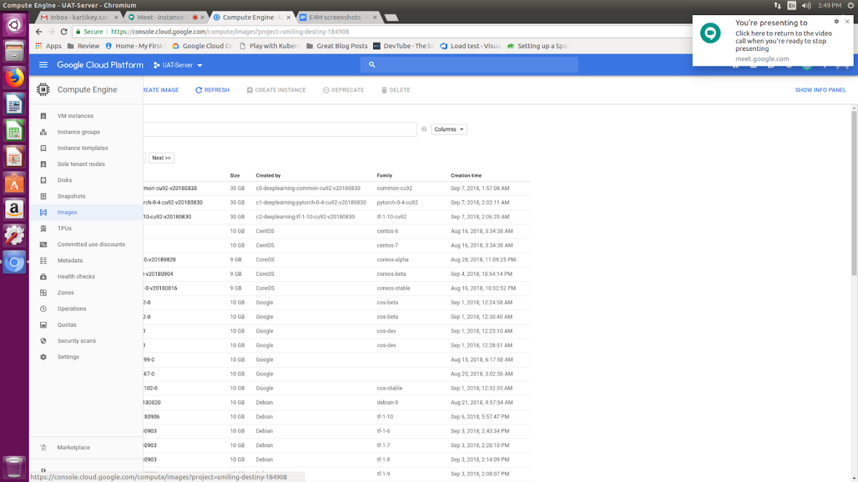

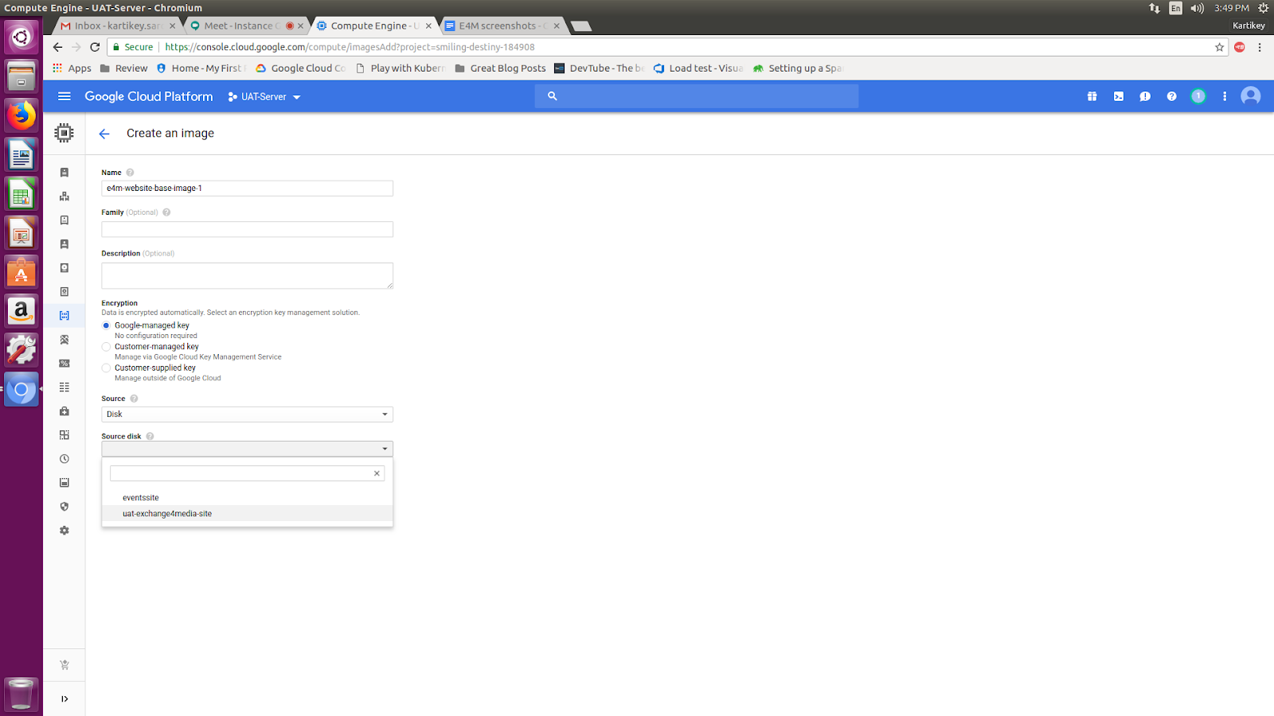

**Template**  
  
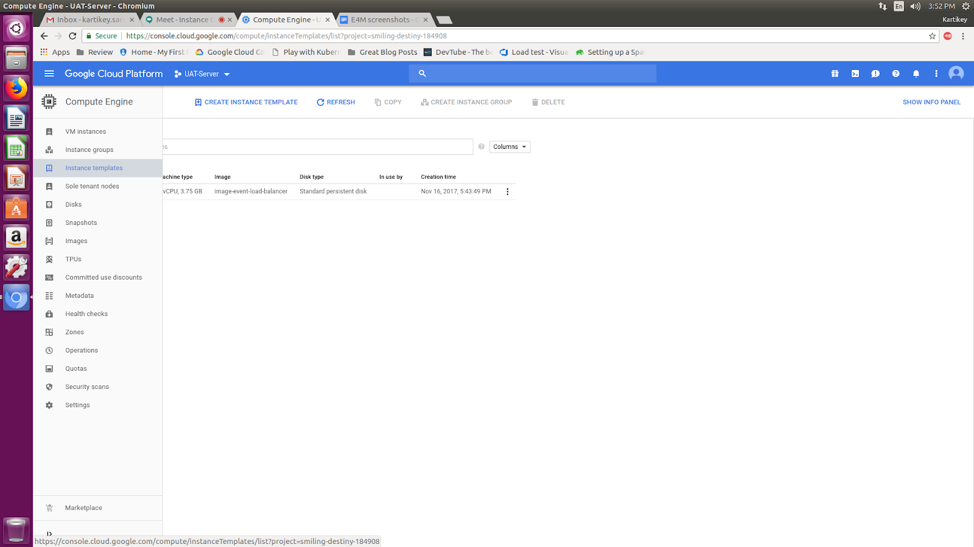

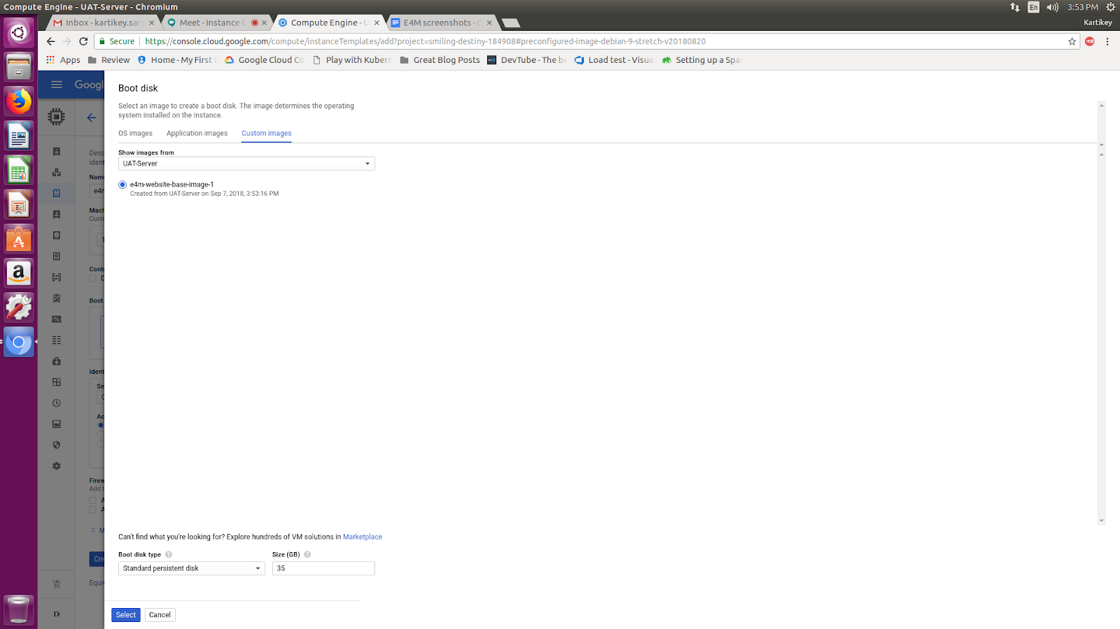

**Instance Group**  
  
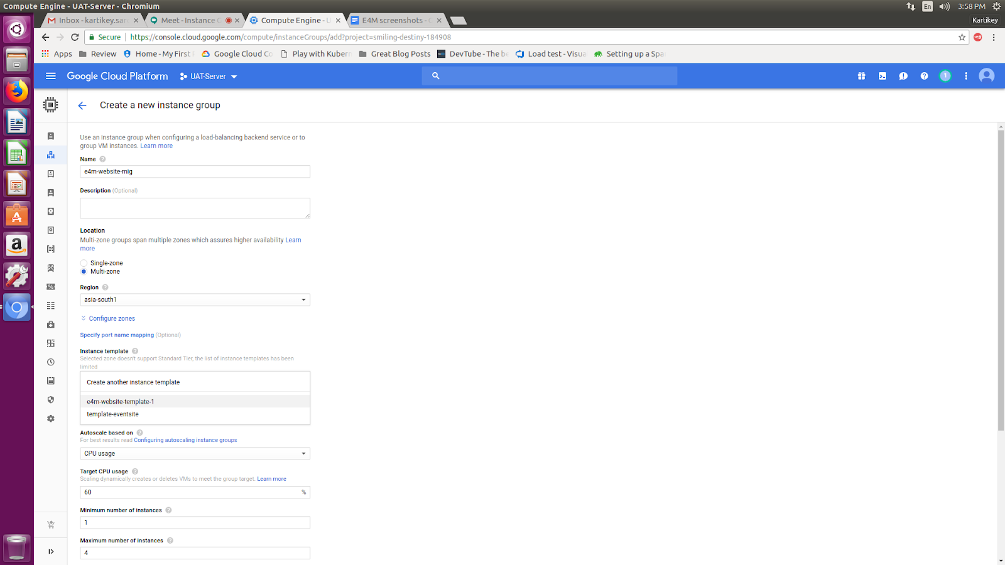

**Load Balancer Section**  
  
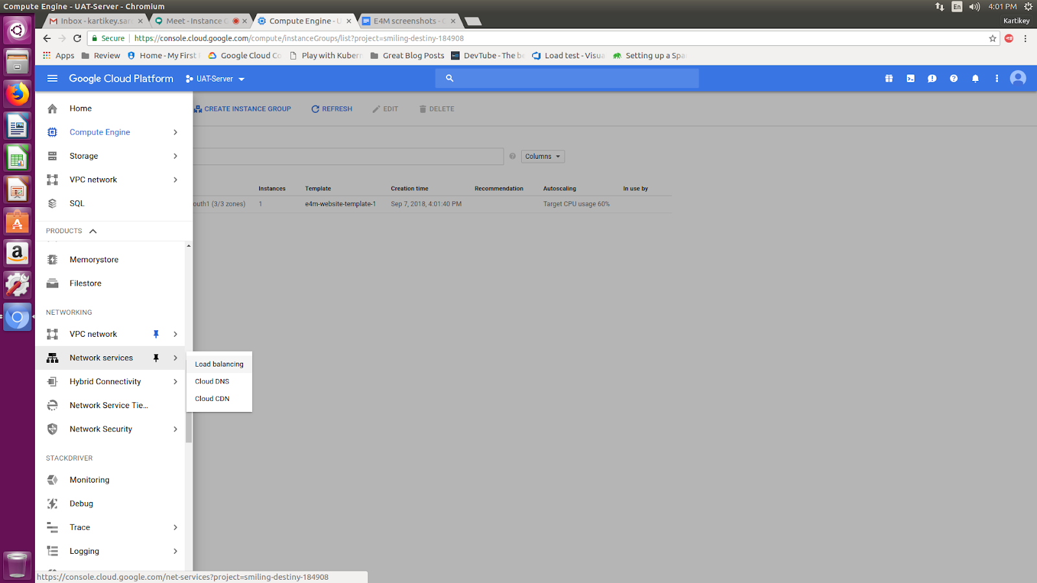

**Backend Service**  
  
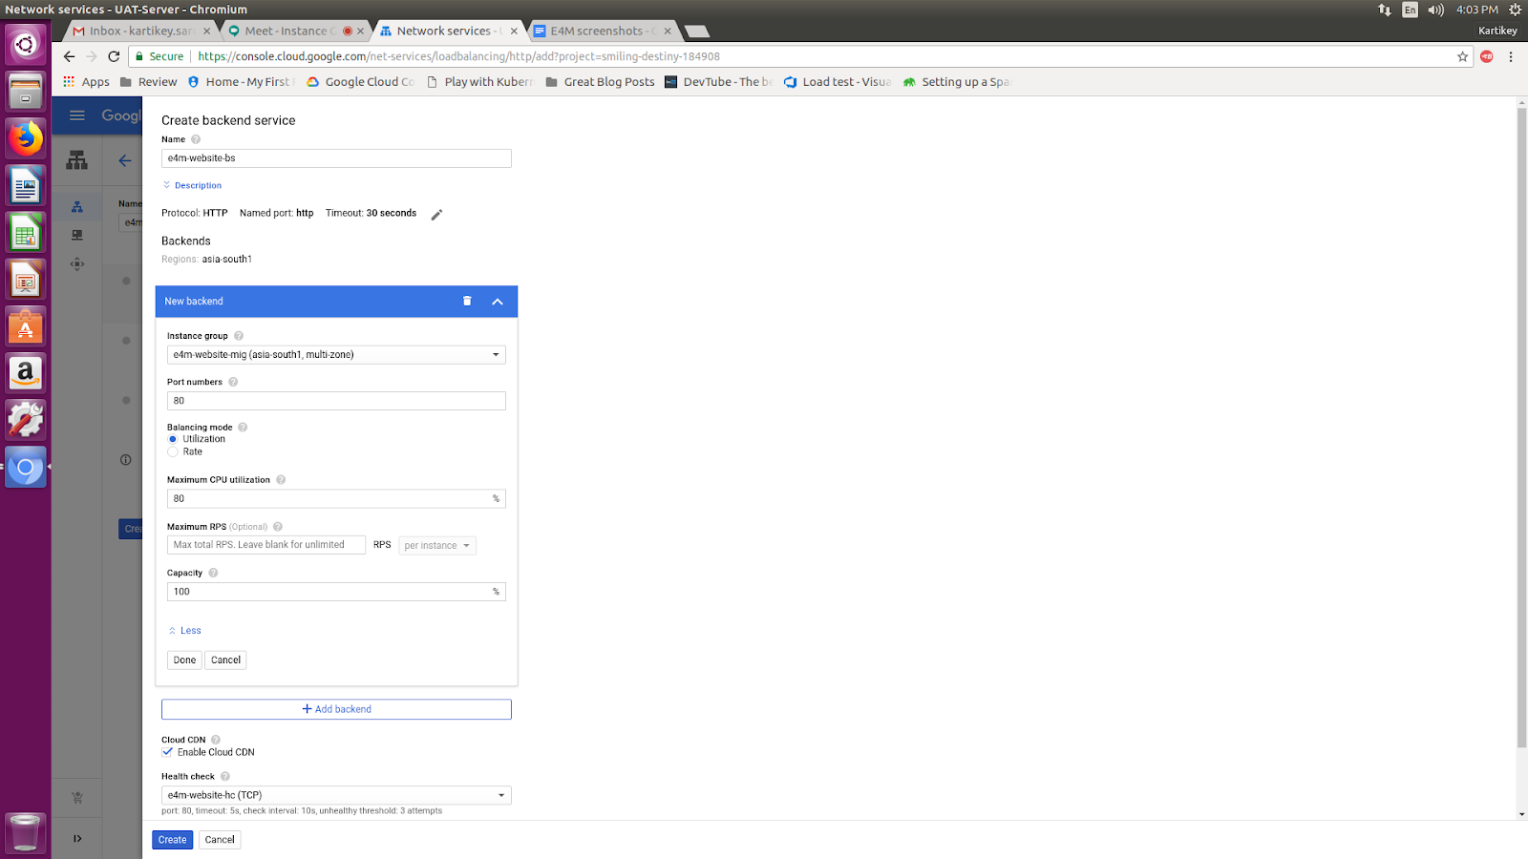

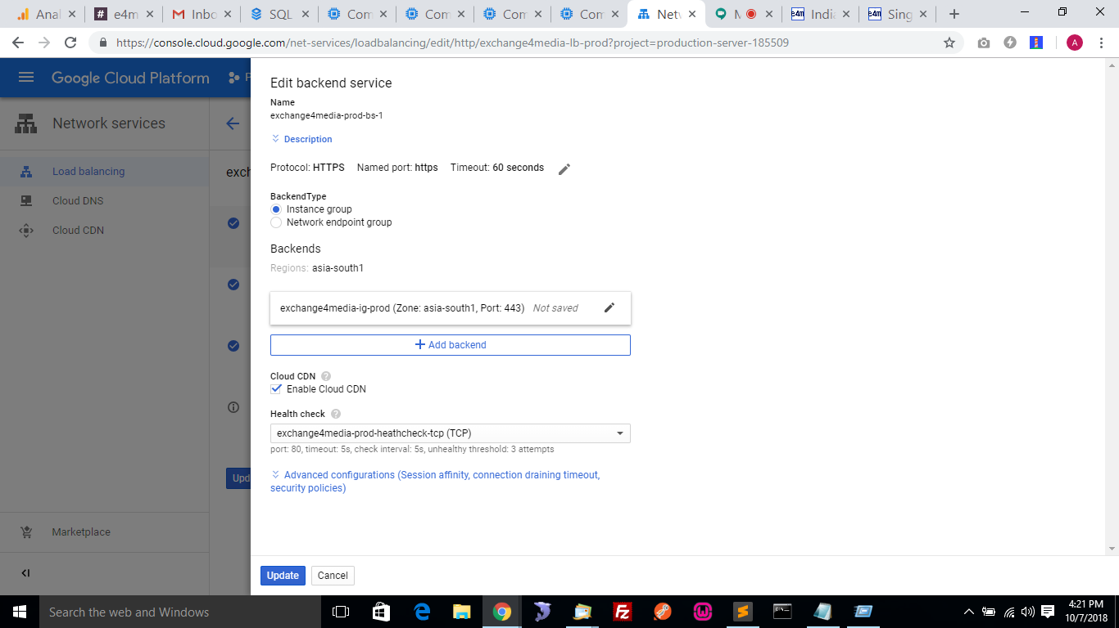

**Frontend**   
  
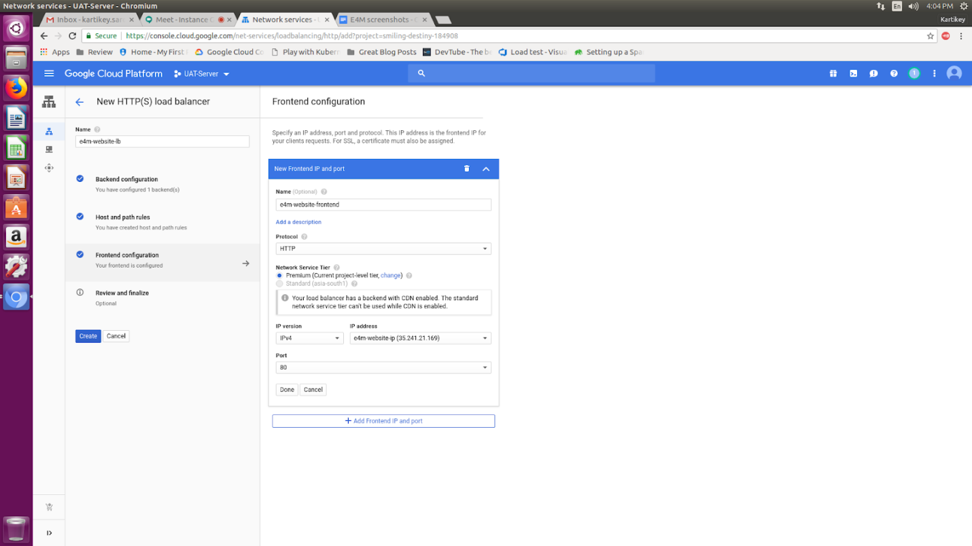

**Load Balancer IP : 35.241.21.169**

**Rolling Update**

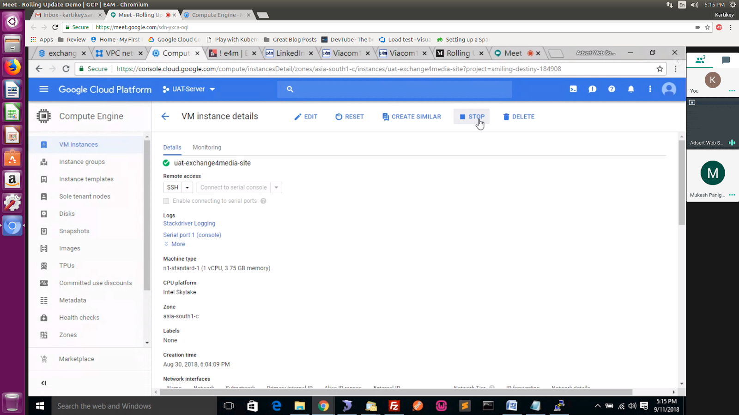

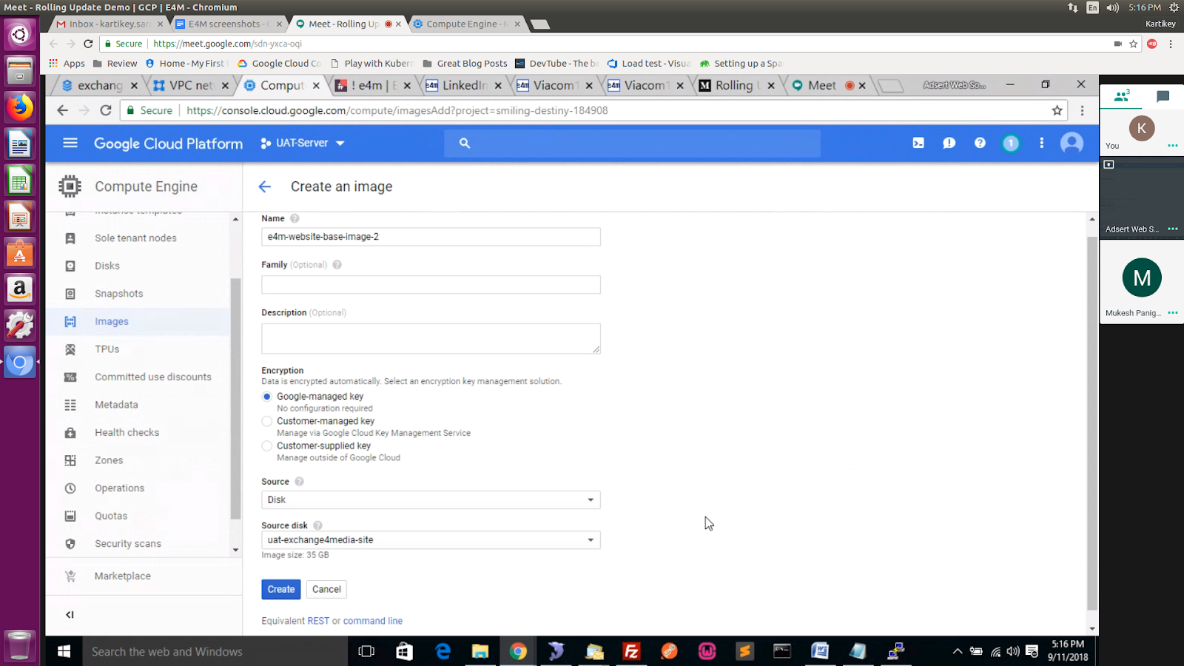

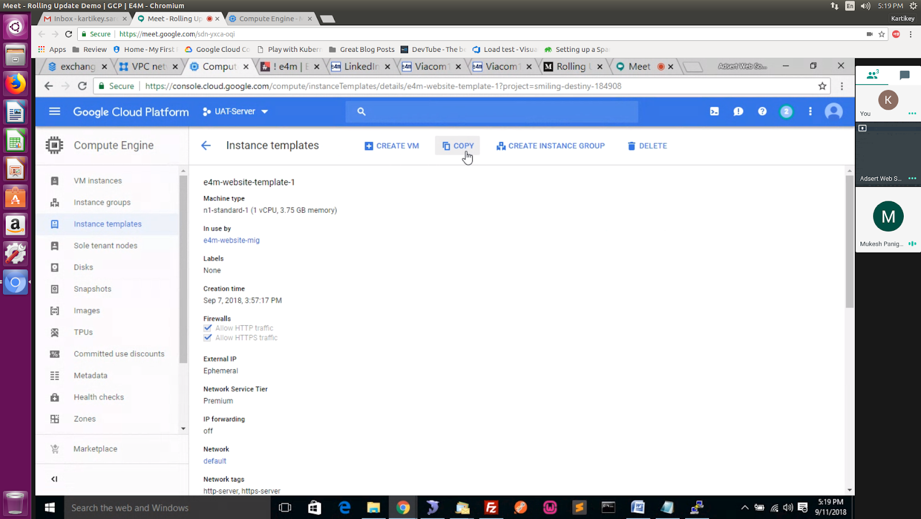

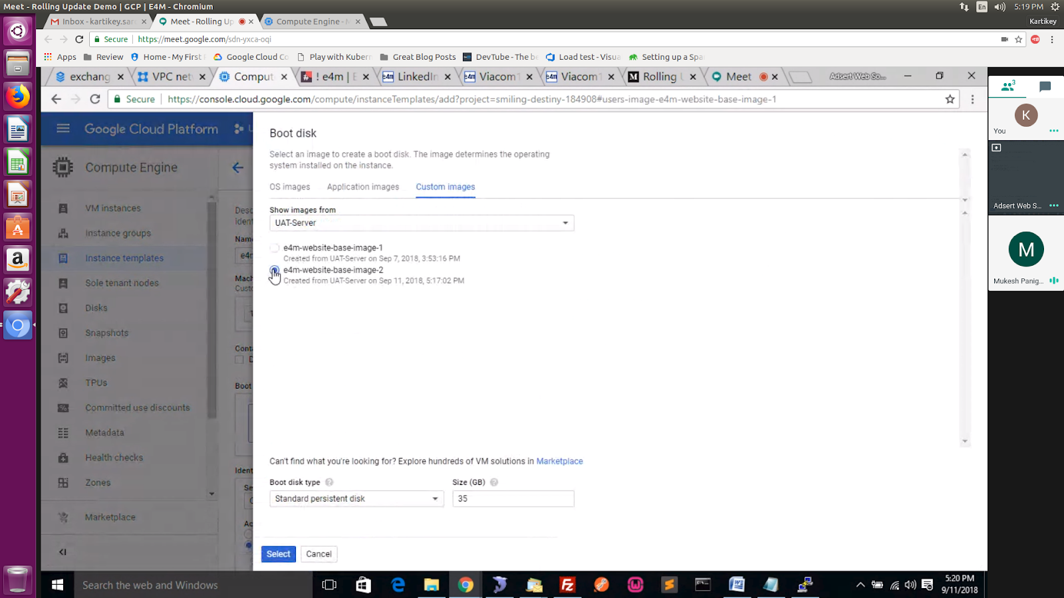

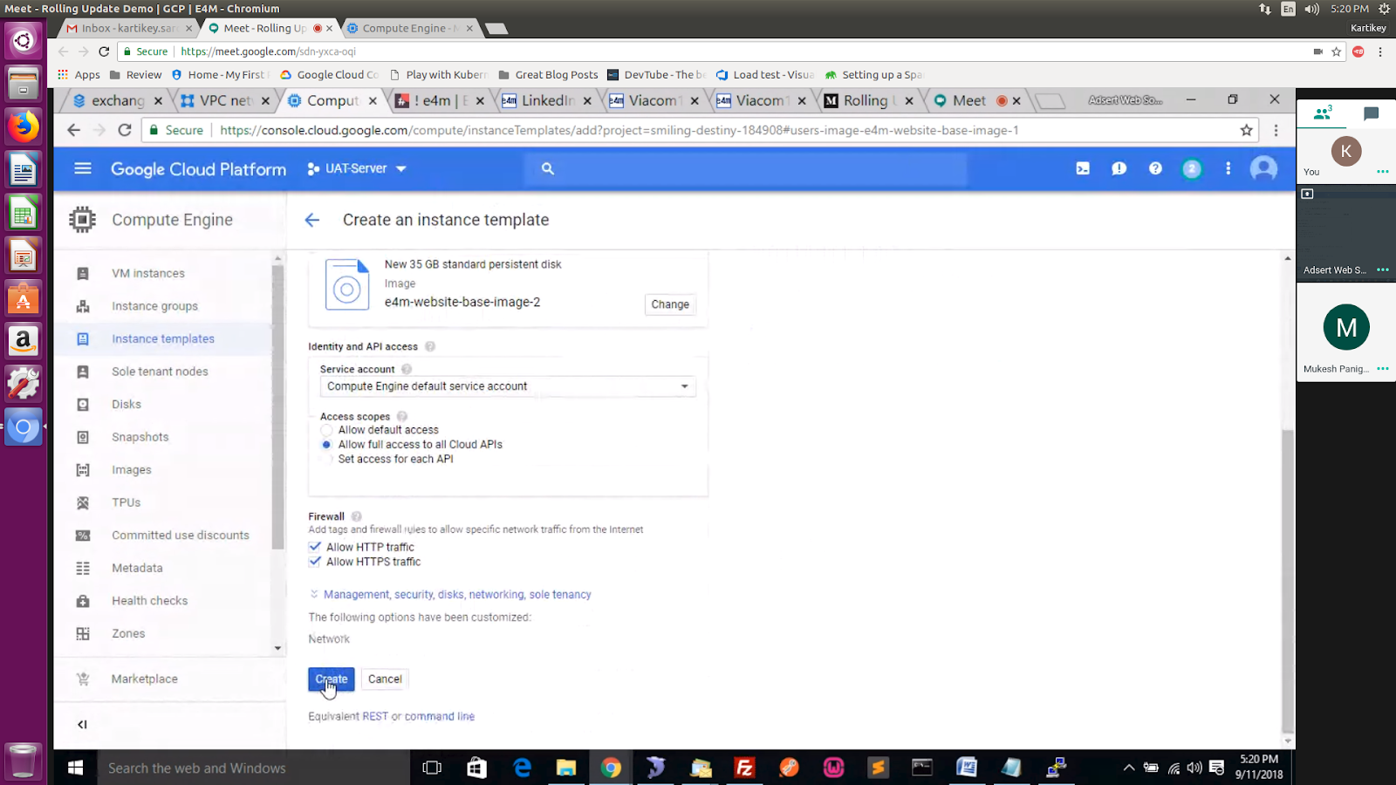

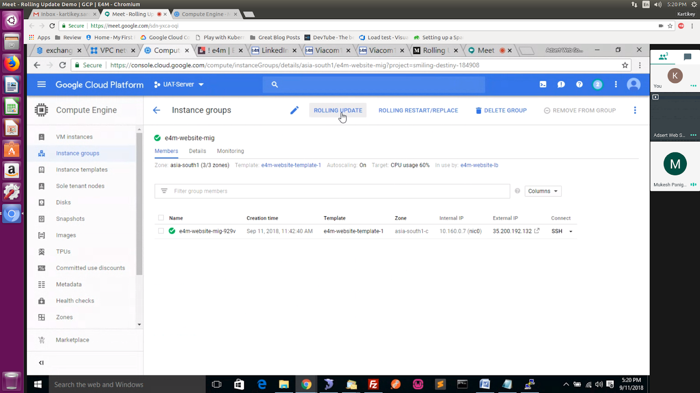

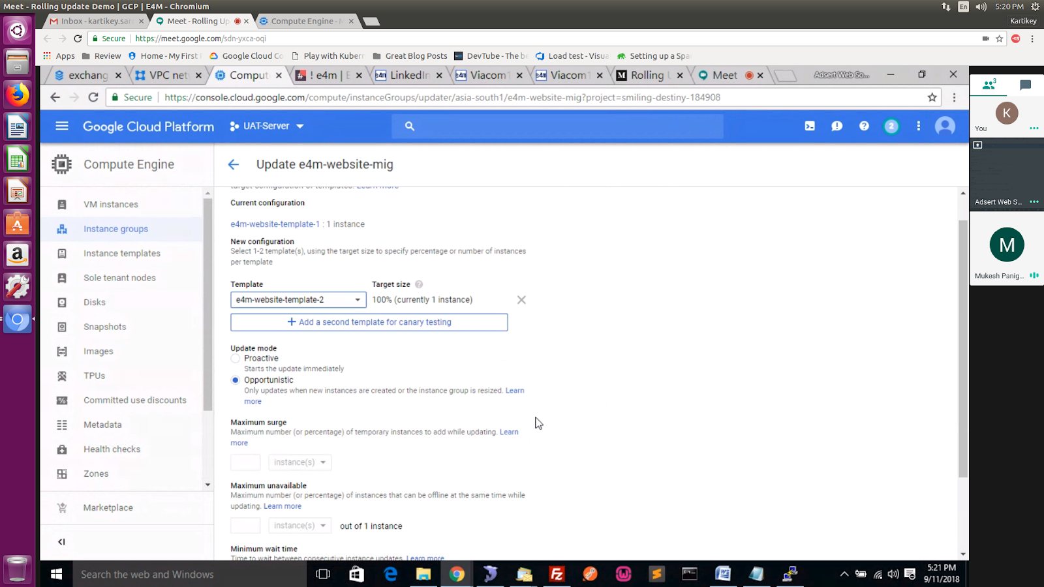

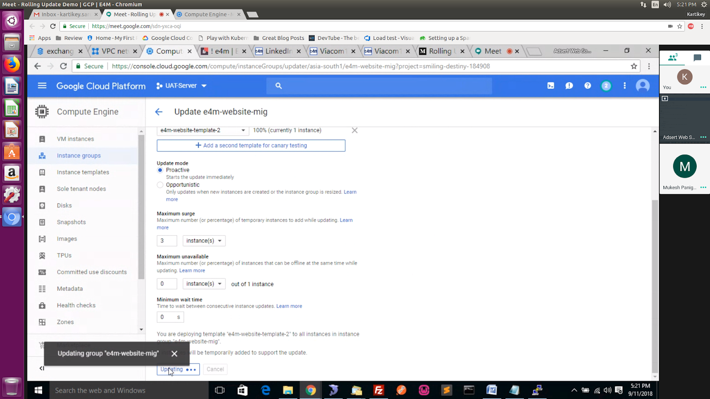

06th oct 10 am :

In Final Day: (current Server)

Take Snapshot and copy to UAT (bucket)

Copy the contents of below folder in storage bucket

1. extra_large_image

2 mastervideothumb

3. album

4. author

5. newsletterhtml

Live the site

1. Take image of uat server.

2. In production server : create base server using UAT image.

3. Changes all the setting.

4. Create image

5. Create template

6. Create group

7. Create Load Balancer (Health Checkp) : TCP

8. HTTPS:

Create a dummy redirection in Web Server where if the user hits /health check then it returns 200 response code